Answers

Physics 11 2007
Motion Test
Answers to questions to be written in the space provided

Answers to questions involving calculations should be evaluated and given in decimal form.
Quote the final answer to not more than four significant figures.

Marks maybe deducted for not showing working.
Working must be legible and clearly set out.

Questions containing the instruction estimate may give insufficient numerical data for their solution. Students should provide appropriate figures to enable an approximate solution to be obtained.

Name __________________________

Teacher__________________

Mark__________

- A rubber ball strikes a wall head-on at 8.00 ms^{–1}. It rebounds with a speed of 5.00 ms^{–1}.The ball has a mass of 0.500 kg. What is its change in momentum?
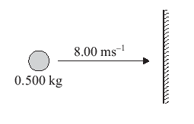
Δv = final velocity – initial velocity
⇨ Δv = 5 ms⁻¹ ← - 8 ms⁻¹→
⇨ Δv = 5 ms⁻¹ ← + 8 ms⁻¹ ←
⇨ Δv = 13 ms⁻¹ ← 

Now Δp = mΔv
⇨ Δp = 0.500 x 13
⇨ Δp =6.50 kgms⁻¹ to the left 

2.
The football commentator says "Going into the half time break, the Dockers have the momentum." The headlines declare "Fremantle Gaining Momentum." The coach pumps up his team at half-time, saying "You have the momentum; the critical need is that you use that momentum and bury them in this third quarter." Compare this description of momentum with your understanding of what we mean when we talk about momentum in physics.
A team that has the momentum is on the move and is going to take some effort to stop. A team that has a lot of momentum is really on the move and is going to be hard to stop. If an object is in motion ("on the move") then it has momentum.All objects have mass; so if an object is moving, then it has momentum. The amount of momentum which an object has is dependent upon two variables: its mass and how fast the mass is moving. Momentum depends upon the variables mass and velocity. In terms of an equation, the momentum of an object is equal to the mass of the object times the velocity of the object.



The Empire State Building in New York is the site of an annual marathon to climb the stairs. There are 1576 stairs to climb, each 20.0 cm wide, beginning in the building's lobby up to the finish point. The altitude difference is 303m. This year’s winner in the stair climb was Rudolf Reitberger in a time of 10 minutes 24 seconds. Estimate the average power that Rudolf developed? Make any necessary assumptions.
Assume mass is 70 kg
P = work/time
⇨ P = mgh/t
⇨ P = 70.0 x 9.8 x 303/624
⇨ P = 333 W

Long Answers
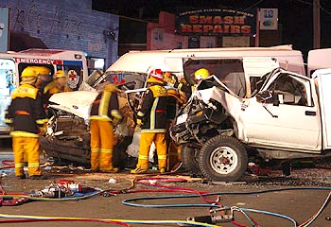
[13 marks]
Consider the head on accident shown in the picture. A four wheel drive car and its driver have a combined mass of 1.20 x 10³ kg. The car collided head on with a stationary van of mass 1.50 x 10³ kg. The car and van locked together after impact and from the marks on the road the police were able to deduce that the wreckage moved at 4.00 m s^{–1} immediately after the collision.
  - Calculate the speed of the car just before it collided with the van.
[2 marks]
m_{c} = 1.20 x 10³ kg Σp_{i} = Σp_{f} ✓
u_{c} = ? ⇨ m_{c}u_{c} + m_{v}u_{v} = m _{c+v} + v _{c+v}
m_{v} = 1.50 x 10³ kg ⇨ 1200uc + 0 = 2700 x 4
v _{c+v} = 2700 kg ⇨ u_{c} = 9.00 ms⁻¹ ✓
  - Apart from momentum, state another physical quantity conserved in the collision.
[1 marks]
^{Energy} ✓
  - In the collision, momentum is conserved. Why is the change in momentum zero?
[2 marks]
Δp = 0
- Σp_{initial} = Σp_{final}✓
- Ft = Ft
F is the same according to 3rd law and as t is also the same then Δp = 0 ✓

  - The impact lasted for 0.50 seconds. Calculate the average force that the car exerted on the van during the collision.
[3 marks]
Δp = m Δv
- Δp = 1200 (9.0-4.0)
- Δp = 6.0 x 10³ kgms⁻¹ ✓
Now F = Δp/t ✓
- F = 6.0 x 10³/0.5
- F = 1.20 x10⁴ N ✓

  - Explain two features that a car has in order to reduce injury to the driver during a collision.
[3 marks]
Air bags; crumple zones; padded dash; seat belts, rigid cage etc. ✓✓
Most rely on increasing the time over which the momentum change of the driver takes place. ✓✓
  - Use calculations to explain whether the collision was elastic or inelastic.
[2 marks]
If elastic ΣEk_{i} = ΣEk_{f} (if elastic) ✓
- 1/2m_{c}u_{c}² + 1/2m_{v}u_{v}² = 1/2m_{c+v} v_{c+v}²
- ½ 1200 (9)² + 0 = ½ (1200+1500)(4)²
- 48.6 x 10³ = 21.6 x 10³
- Collision not elastic since kinetic energy not conserved✓
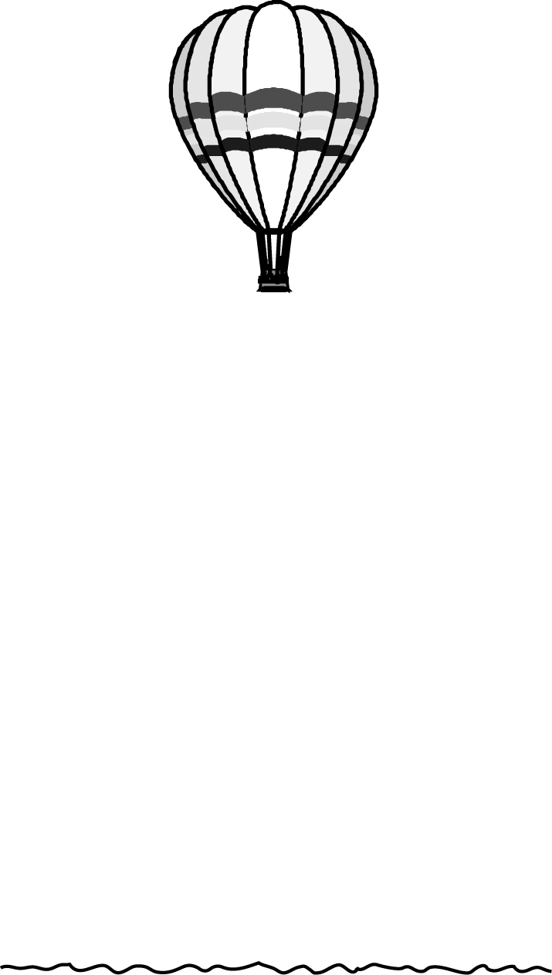
- [15 marks]
A hot air balloon of mass 600 kg is rising vertically at a constant speed of 2.5 m s^{–1}.
  - Compare the sizes of the total upward force acting on the hot air balloon with the total downward force acting on it, giving your reasons.
[2 marks]
Total force up = Total force down✓ as the balloon is not accelerating ✓
As the balloon is rising, a 5.0 kg ballast sandbag falls from the basket at the instant the balloon is 1267m above the ground.
  - Neglecting air resistance, determine how long it takes the sandbag to reach the ground and determine how fast is it traveling on impact?
[5 marks]
Taking down +ve
v² = u² + 2 as ✓
u = -2.50 m s⁻¹ ✓ ⇨ v² = (-2.5)² +2(9.8) (1267)
s = 1267 m s⁻¹ ⇨ v = 157 m s⁻¹ ✓
t = ?
g = 9.80 m s⁻² now

v = u +at ✓
⇨ 157 = -2.5 +9.8t
⇨ t = 16.3 s ✓
  - Neglecting air resistance, sketch a graph to show the following relationships for the sandbag from the moment it leaves the balloon to the time it hits the ground.
[4 marks]

    - velocity against time
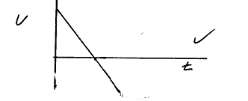
    - acceleration against time
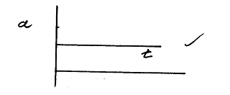
    - Displacement against time.
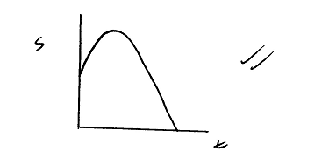
  - The balloon now descends and lands on the ground. If the uplift provided by the gas in the balloon amounts to 15% of its weight, what normal reaction force does the ground exert on the basket?
[4 marks]
R = 0.85 mg ✓
⇨ R = 0.85 (595) (9.80) ✓ (mass now 595 kg)
⇨ R = 4.96 x 10³ ✓ upwards ✓

